AIM Student Exam Scheduling

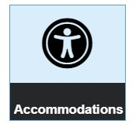
- Open TechWeb and click on the Accommodations Tile

- In AIM click on the “Alternative Testing” link on the far right hand side-bar menu

- Select the appropriate course from the drop down menu and click on “ Schedule an Exam”
*If your course does not appear please contact your instructor. Your instructor must submit their testing agreement before a test can be scheduled.

- Fill out the prompts accordingly and select what accommodations you would like to utilize. Click on “Add Exam Request”
